“DataSetu: A B2B Business Networking and Associate Management Platform”

Comprehensive Project Report

Submitted in Partial Fulfillment of the
Requirements for the Degree of

BACHELOR OF TECHNOLOGY

IN

COMPUTER SCIENCE & ENGINEERING

By

Krish Modi

22BCP426

Under the Guidance of

Dr. Shakti Mishra



Department of Computer Science & Engineering,
School of Technology, Pandit Deendayal Energy University,
Gandhinagar 382 426

May 2026

Certificate of Originality of Work

I hereby declare that the B.Tech. Project entitled DataSetu: A B2B Business Networking and Associate Management Platform submitted by me for the partial fulfillment of the degree of Bachelor of Technology to the Dept. of Computer Science & Engineering at the School of technology, Pandit Deendayal Energy University, Gandhinagar, is the original record of the project work carried out by me under the supervision of Dr. Shakti Mishra

I also declare that this written submission adheres to university guidelines for its originality, and proper citations and references have been included wherever required.

I also declare that I have maintained high academic honesty and integrity and have not falsified any data in my submission.
I also understand that violation of any guidelines in this regard will attract disciplinary action by the institute.

Name of the Student: Krish Modi

Roll Number of the Student: 22BCP426

Signature of the Student:

Name of the Supervisor: Mit Patel

Designation of the Supervisor: Chief Technical Officer, Marwiz Pvt. Ltd.

Signature of the Supervisor:

Place:

Date:

Certificate from the Project Supervisor/Head

This is to certify that the Comprehensive Project Report entitled “DataSetu: A B2B Business Networking and Associate Management Platform” submitted by Mr. Krish Modi Roll No. 22BCP426 towards the partial fulfilment of the requirements for the award of degree in Bachelor of Technology in the field of Computer Science & Engineering from the School of technology, Pandit Deendayal Energy University, Gandhinagar is the record of work carried out by him under our supervision and guidance. The work submitted by the student has in our opinion reached a level required for being accepted for examination. The results embodied in this major project work to the best of our knowledge have not been submitted to any other University or Institution for the award of any degree or diploma.

Name and Sign of the Supervisor | Name and Sign of the Industry Supervisor
Name and Sign of the HoD | Name and Sign of the Director
Place
Date

Acknowledgement

“When working together, you can do so much more than you can do alone, and the greatest value of collaboration is the wisdom that's shared along the way.”

We consider it a privilege to express our heartfelt gratitude to all those who have been a source of guidance, strength, and inspiration throughout the journey of completing this project.
First and foremost, we extend our sincere thanks to our project guide, Dr. Shakti Mishra, Department of Computer Science & Engineering, for their invaluable mentorship, constructive feedback, and constant encouragement. Their technical insight and patience have been the backbone of this project's success.
We are also deeply grateful to our Head of Department, Dr Shakti Mishra, and the entire faculty of the department for providing us with the academic foundation and resources necessary to undertake a project of this scale.
Above all, we owe our deepest gratitude to our parents, whose unconditional love, unwavering faith, and countless sacrifices have made us who we are today. Their silent support through every late night, every challenge, and every moment of self-doubt gave us the strength to persevere and deliver our best.
This project is as much a result of their belief in us as it is of our own efforts.

Krish Modi

Abstract
While large firms are making strides towards adopting more sophisticated approaches for business networking and partnerships, SMEs continue to use fragmented and informal mechanisms for finding partners, business referrals, and networking- thus restricting themselves from reaching scale. In light of the ever-changing nature of the digital economy, this paper proposes an ecosystem called DataSetu for helping India's 63 million MSMEs find better solutions for networking and business partnerships.
The proposed platform is made up of five integrated sub-systems: a React Native mobile app (iOS & Android), React + Vite web portal, Node.js + Express.js REST API server, super-admin control panel, and associate broker dashboard running on a common back-end platform featuring over 100 API endpoints and 107 MongoDB collections hosted on MongoDB Atlas.
This platform offers a host of features, which include OTP authentication system, intelligent business discovery engine employing 3072 dimensions vector embeddings using AI for similarity, MeiliSearch based full text search service with sub-50ms query response time, and meetings management system that caters to physical, virtual, and hybrid meetings. Communication functionality is provided through Socket.IO and notification services include Firebase Cloud messaging, WhatsApp Business API and transactional email services.
Payment processing is handled through Razorpay for Android and Web, and Apple In-App Purchases for iOS, abstracted into a unified transaction model. The platform further incorporates a loyalty points system, coupon management, contact sync and invite, and PDF/Excel export capabilities.
Security is enforced through JWT-based RBAC, rate limiting, input sanitization, helmet middleware, and bcrypt password hashing. The system achieves an average API response time of under 200ms and has been tested for up to 500 concurrent Socket.IO connections.
The results demonstrate that DataSetu successfully bridges the gap between informal business networking and a structured, digital-first referral economy, offering a scalable, secure, and feature-complete solution ready for real-world deployment.

INDEX

Chapter No. | Title |  | Page No.
 | Acknowledgement |  | i
 | Abstract |  | ii
 | Index |  | iii
 | List of Figures |  | iv
 | List of Tables |  | v
 | Nomenclature |  | viii
1 | Introduction |  | 1
 | 1.1 | Introduction/ Prologue/Background | 1
 | 1.2 | Motivation | 3
 | 1.3 | Objective | 5
 | 1.4 | Problem Statement | 7
 | 1.5 | Approach | 9
 | 1.6 | Scope of the Project | 14
 | 1.7 | Organization of the Rest of the Report | 17
2 | Literature Review |  | 18
 | 2.1 | Previous Approaches to Solve the Problem | 19
3 | Software Design |  | 22
4 | Results and Discussion |  | 28
5 | Conclusions and Future Scope |  | 31
 | References |  | 33
 | Appendix |  | 34

LIST OF FIGURES

Figure No. | Title | Page No.

LIST OF TABLES

Table No. | Title | Page No.

NOMENCLATURE

Acronym | Full Form
MSMEs | Micro, Small, and Medium Enterprises
B2B | Business-to-Business
OTP | One-Time Password
AI | Artificial Intelligence
JWT | JSON Web Token
RBAC | Role-Based Access Control
FCM | Firebase Cloud Messaging
IAP | In-App Purchases
SDK | Software Development Kit
ODM | Object Document Mapper
CRUD | Create, Read, Update, Delete
TTL | Time-to-Live
CORS | Cross-Origin Resource Sharing
API | Application Programming Interface
UPI | Unified Payments Interface

Chapter 1 -Introduction

1.1 Overview
For enterprises of all sizes, the power to establish valuable business relationships and efficiently manage business networks is a vital competitive edge in today's digitally driven business landscape. While there are more than 63 million micro, small, and medium enterprises (MSMEs) in India, most still rely on informal and unstructured means to network and find partners for B2B activities. This is a huge disconnect, and one that must be solved using a digital-first solution.
Data Setu's B2B business networking and associate management platform is a full stack, cross-platform solution designed to fill the very breach. The name Data Setu, which translates to 'Bridge of Data', highlights its core focus of bringing businesses together via intelligent, data-driven networking solutions.
1.1.1 What is DataSetu?
Data Setu allows the verified business professionals to find the relevant parties, book and manage appointments, interact in real-time, opt into tiered pricing programs, and join a commission-based referral system, all within one single platform.
Rather than just a networking site, it's a full-fledged business relationship management system that automates the entire process of finding and engaging with a B2B connection, from discovery to communication, collaboration, and development.

1.1.2 System Architecture & Sub-Systems
Data Setu comprises six tightly integrated sub-systems, each serving a distinct role within the ecosystem:
Sub-System | Technology | Role
Data Setu (Mobile App) | React Native (Expo) | End-user mobile interface for iOS & Android
Data Setu Web Portal | React 18 + Vite | Browser-based user portal for desktop users
Data Setu Server | Node.js + Express.js | Unified REST API backend (100+ endpoints)
Data Setu Admin Panel | React (CRA) | Super-admin control and management panel
Data Setu Broker Panel | React (CRA) | Associate/broker referral dashboard
Email & WhatsApp Service | Node.js + Nodemailer / WhatsApp API | Transactional notification microservices
1.1.3 Core Technology Stack
The platform is built using carefully chosen, modern, production-grade technology that is optimized for performance, scalability and cross-platform compatibility:
- Database: MongoDB Atlas (Cloud NoSQL) with 107 collections and support for vectors search
- Authentication: 2FA by email and JWT access token
- AI-Powered Search: OpenAI 3072 dimensional vector embeddings with MongoDB Atlas Vector Search.
- Full-Text Search: MeiliSearch is a sub-50ms query response search engine.
- Real-Time Communication: Socket.A live in-app messaging service for iOS.
- Payment methods: Razorpay (Android & Web) + Apple In-App Purchases (iOS)
- Notifications: Firebase Cloud Messaging (FCM), WhatsApp Business API, SMTP Email

1.1.4 Key Highlights of the Platform
Data Setu stands out through several distinguishing capabilities:
- An AI-powered verified business directory, based on semantic vector similarity with “Similar business” suggestions.
- A system for managing structured meetings, which includes physical, virtual (webinar) and hybrid (mixed) meetings, including an agenda and participant tracking.
- A tiered associate commission structure, with brokers receiving increasing commissions based on their tier (Silver → Gold → Platinum) when they send paying users to the platform
- One platform for in-app messaging, push notifications, WhatsApp and email.One communication platform to manage all channels.
- A loyalty and coupon mechanism that encourages user behaviour on the platform.A loyalty and coupon mechanism to encourage user behaviour on platform.
1.2. Motivation

1.2.1 The B2B Networking Gap in India
India is home to over 63 million micro, small, and medium enterprises (MSMEs), making it one of the largest SME ecosystems in the world. Despite this scale, industry surveys consistently reveal that over 70% of B2B partnerships are still formed through informal word-of-mouth channels personal contacts, physical meetups, and unverified referrals. This heavy dependence on informal networking severely limits the growth potential of businesses that lack strong personal connections or geographical reach.
There exists a significant absence of structured, verified, and digital-first platforms that cater specifically to the B2B segment within India's SME landscape. Data Setu was conceived to fill precisely this void providing a centralized, intelligent, and scalable ecosystem where businesses can connect, collaborate, and grow.

1.2.2 Limitations of Existing Solutions
While several networking platforms exist globally, none adequately address the specific needs of Indian SMEs:
- LinkedIn :- Although the world's largest professional network with over 900 million users, LinkedIn is broadly generalist. It lacks dedicated features for structured B2B meeting management, regional business discovery, credit-based contact unlocking, or associate incentivization. It is designed for individual professionals rather than business-to-business relationships.
- BNI (Business Network International):- BNI operates structured referral networking through physical chapter meetings. While effective, it is geographically constrained, expensive to participate in, and lacks a digital audit trail or scalable online infrastructure.
- Alignable:- A U.S.-focused SME networking platform that, while conceptually similar, lacks payment integration, a mobile-first design philosophy, and the associate commission economy that drives organic growth.
- WhatsApp Groups & Physical Events:- Widely used in India for informal business networking, these channels are inherently unscalable, unverified, and provide no structured mechanism for meeting management, discovery, or commission tracking.
Data Setu draws inspiration from the strengths of these platforms while overcoming their individual limitations through a purpose-built, integrated solution.

1.2.3 The Referral Economy Opportunity
Referral-driven growth has consistently proven to be one of the most cost-effective customer acquisition strategies in modern business. Academic research (Biyalogorsky et al., 2001; Schmitt et al., 2011) demonstrates that referred customers exhibit 16-25% higher lifetime value compared to non-referred ones.
Data Setu was motivated by the opportunity to harness this referral economy at scale. The platform introduces a network of "Associates" (Brokers) individuals who earn verified, tiered commissions when the businesses they refer subscribe to the platform. This creates a self-sustaining, incentive-driven growth engine where platform expansion is directly tied to the financial success of its associates, a model that benefits the platform, its associates, and the businesses that join through them.

1.2.4 Communication Fragmentation in Business
One of the most persistent pain points for business professionals today is communication overload and fragmentation. A typical SME owner juggles:
- WhatsApp messages for informal coordination
- Emails for formal communication
- Phone calls for urgent matters
- Physical meetings for relationship building
- Separate tools for scheduling and follow-ups
This constant context-switching between platforms reduces productivity, causes missed follow-ups, and makes it nearly impossible to maintain a clean audit trail of business interactions. DataSetu addresses this by unifying scheduling, real-time messaging, push notifications, WhatsApp, and email within a single platform, drastically reducing friction and improving professional productivity.

1.2.5 The Need for Verified Business Profiles
A critical challenge in B2B networking is trust and verification. Unverified profiles, fake businesses, and spam connections undermine the quality of any networking platform. Data Setu was motivated by the need to build a platform where every registered user undergoes OTP-based email verification and profile completion, ensuring a directory of genuine, active business professionals. This verified foundation makes every connection on Data Setu meaningful and trustworthy.

1.2.6 Technology as the Enabler
The motivation behind Data Setu is equally rooted in the availability of powerful modern technologies that make such a platform feasible:
- AI and vector embeddings now make intelligent business recommendations possible at scale
- React Native enables a single codebase to serve both iOS and Android users
- MongoDB Atlas Vector Search allows semantic similarity matching without a separate ML infrastructure
- Socket.IO enables reliable real-time communication even on variable mobile networks
- Razorpay and Apple IAP provide robust, India-first payment infrastructure
The convergence of these technologies made it the right time to build Data Setu a platform that would have been significantly more complex and expensive to develop just five years ago.

1.3. Objective

1.3.1 Business Discovery and Intelligent Recommendations
The primary objective of Data Setu is to enable verified business users to discover relevant partners, suppliers, and potential clients through an AI-powered discovery engine. The platform uses 3072-dimensional OpenAI vector embeddings stored in MongoDB Atlas Vector Search to deliver semantic "similar business" recommendations. Additionally, MeiliSearch powers real-time full-text search with sub-50ms response time, allowing users to find businesses by name, industry, or keyword with exceptional speed and accuracy.

1.3.2 Structured Meeting Management
Data Setu aims to provide a dedicated, structured system for scheduling, conducting, and recording B2B meetings, a feature entirely absent from existing networking platforms. The meeting module supports physical, virtual, and hybrid formats with agenda management, participant tracking, status updates, and calendar integration, giving SMEs a professional framework to plan and document their business interactions.

1.3.3 Real-Time Communication
The platform implements in-app real-time messaging via Socket.IO, enabling instant communication between connected business users without leaving the application. This eliminates the need to switch to external tools like WhatsApp or email for follow-ups, keeping all business conversations centralized, searchable, and professionally organized within Data Setu.

1.3.4 Subscription Management and Monetization
Data Setu offers tiered subscription plans with a credit-based profile unlocking mechanism, providing a sustainable monetization model. Payment processing is integrated with Razorpay for Android and Web users, and Apple In-App Purchases for iOS users, all abstracted into a single unified transaction model that handles platform-specific payment flows transparently.

1.3.5 Associate Commission System
A core objective of the platform is to build a transparent, automated, and target-driven commission system for associates who refer new users to the platform. The system manages locked and available commission balances, automates tier promotion from Silver to Gold to Platinum based on cumulative referral targets, and provides a complete withdrawal workflow, reducing administrative overhead while incentivizing organic platform growth.

1.3.6 Loyalty and Engagement
Data Setu implements a loyalty points system to reward users for active platform engagement. Points are earned through activities such as profile completion, meeting participation, and referrals, and can be redeemed as discounts or coupons on subscription renewals, encouraging consistent, long-term usage of the platform.

1.3.7 Multi-Channel Notification Infrastructure
The platform aims to deliver timely and contextually relevant notifications across multiple channels. Firebase Cloud Messaging handles push notifications to mobile devices, while dedicated microservices manage WhatsApp Business API messages and transactional emails via SMTP. This ensures users are promptly informed about critical events such as payment confirmations, meeting reminders, commission releases, and connection requests.

1.3.8 Administrative Control and Oversight
DataSetu provides administrators with a dedicated admin panel offering granular control over every aspect of the platform, including user management, subscription plans, industry classifications, commission plan configuration, coupon issuance, WhatsApp and email campaigns, and financial operations such as commission release and withdrawal approvals.

1.3.9 Contact Sync and Platform Growth
To accelerate user acquisition, Data Setu allows registered users to sync their phone contacts and identify which of their existing contacts are already on the platform. For those who are not, users can send personalized invitations, turning every existing user into a potential growth channel for the platform.

1.4. Problem Statement

1.4.1 Core Problem
India's 63 million MSMEs operate in one of the world's most competitive and diverse business environments, yet the infrastructure supporting their professional networking remains fundamentally broken. Business owners spend more time finding the right partners than actually working with them. Referrals happen over chai conversations. Meetings are tracked in WhatsApp threads. Commissions are calculated on spreadsheets. There is no single, trusted, digital space where Indian SMEs can discover partners, transact, communicate, and grow, reliably and at scale.Data Setu was built to solve exactly this.
"Design and implement a scalable, secure, and feature-rich B2B business networking platform that enables small and medium enterprises to digitally discover business partners, manage meetings, and participate in a referral-driven growth economy, while providing robust administrative oversight and a unified communication infrastructure."

1.4.2 Specific Problems Addressed

P1:- Fragmented Business Discovery
Business professionals have no centralized, verified database of potential B2B partners that can be filtered by industry, city, business type, or relevance. Discovery today happens through personal contacts, physical events, or generic platforms like LinkedIn that are not designed for B2B matching. Without a structured discovery mechanism, businesses miss out on partnerships that could genuinely benefit them simply because they never crossed paths.Data Setu addresses this by building a MongoDB-backed verified business directory enriched with 3072-dimensional OpenAI vector embeddings, enabling AI-powered semantic similarity matching that surfaces the most relevant business recommendations, even when the user does not know exactly what they are looking for.

P2:- Unstructured Meeting Management
There exists no dedicated tool for SMEs to plan, schedule, and track B2B meetings with the professionalism the context demands. Meetings are arranged over WhatsApp, details are shared informally, agendas are rarely documented, and follow-ups are easily missed. This lack of structure leads to low meeting productivity and poor relationship building. DataSetu introduces a structured meeting model supporting physical, virtual, and hybrid formats with agenda management, participant tracking, status updates, and calendar integration, bringing the discipline of enterprise meeting tools to the SME segment.

P3:- Absence of a Referral Incentive System
Existing networking platforms provide no financial incentive to individuals who actively drive platform growth through referrals. In reality, it is these connectors, brokers, consultants, and community leaders who are best positioned to bring new businesses onto a platform. Without a structured incentive, their efforts go unrecognized and unmonitored. Data Setu introduces a tiered Associate Commission System where referred user payments unlock progressive commissions:- Silver at 10%, Gold at 15%, and Platinum at 20% based on cumulative target achievement. This transforms referral activity from an informal favor into a measurable, rewarding profession.

P4:- Communication Silos Across Multiple Platforms
Business communication today is scattered across WhatsApp, email, phone calls, and in-person interactions with no unified record or audit trail. Important decisions made over a WhatsApp message get buried. Follow-up emails go unanswered. There is no single thread that captures the complete history of a business relationship. Data Setu unifies real-time messaging via Socket.IO, meeting scheduling, push notifications, WhatsApp messages, and email communication within one platform, giving every business relationship a clean, traceable, and professional communication history.

P5:- Payment Complexity Across Platforms
Handling subscriptions across Android, iOS, and Web involves fundamentally different payment systems Razorpay for Android and Web, and Apple's In-App Purchase framework for iOS each with its own integration requirements, webhook structures, and receipt validation mechanisms. Managing these separately introduces significant development complexity and inconsistency in transaction records.Data Setu abstracts all payment flows into a single unified transaction model with platform-aware processing logic, ensuring consistent subscription management and commission calculation regardless of which device or platform the payment originated from.

1.4.3 Previous Approaches and Their Limitations
Several solutions have been attempted over the years to address parts of this problem. Each brought value in its own context but fell short of delivering a complete, scalable answer.

Approach 1:- Physical Networking Events (BNI Model)
Business Network International popularized the concept of structured referral networking through weekly physical chapter meetings. Members introduce their businesses, pass referrals, and track outcomes manually. While effective for building trust, this model is geographically restricted, expensive to sustain, entirely offline, and scales poorly. There is no digital record of referrals, commissions are handled informally, and participation requires physical presence making it inaccessible to businesses in smaller cities or those with time constraints.

Approach 2:- General Professional Networks (LinkedIn)
LinkedIn brought professional networking to the digital world at a massive scale. However, its design philosophy is centered around individual career growth rather than B2B business relationships. It offers no structured meeting management, no credit-based contact unlocking for SMEs, no regional business discovery filters, and absolutely no mechanism to incentivize or compensate individuals who drive platform referrals. For an Indian SME owner looking to find a supplier in their city or reward a broker who brought them a client, LinkedIn offers no practical solution.

Approach 3:- WhatsApp Groups and Informal Digital Channels
In the absence of better tools, Indian SMEs adopted WhatsApp groups as their de facto networking platform. Industry groups, city-level business communities, and broker networks all operate on WhatsApp. While accessible and familiar, this approach has severe limitations there is no profile verification, no meeting management, no commission tracking, no search capability, and messages are ephemeral. Important business conversations get lost in a flood of forwards and casual chatter.

Approach 4:- Generic CRM and Business Tools
Some businesses attempted to piece together a solution using generic CRM platforms like Zoho or HubSpot for contact management, Calendly for meeting scheduling, and Excel for commission tracking. While each tool is capable in isolation, this approach requires significant manual effort to keep data synchronized across systems, offers no networking or discovery capability, and provides no referral or commission automation. The cognitive overhead of managing multiple tools defeats the purpose of digitization.

1.4.4 The Need for Data Setu
The collective failure of these previous approaches reveals a clear pattern: no existing solution addresses the full spectrum of needs of an Indian SME in one place. Physical events lack scale. LinkedIn lacks B2B specificity. WhatsApp lacks structure. CRM tools lack networking. Niche platforms lack local relevance.
Data Setu was designed with this gap in mind not as an incremental improvement to an existing tool, but as a ground-up reimagination of what B2B networking infrastructure for Indian SMEs should look like in the digital age.
1.5. Approach

1.5.1 Development Philosophy
DataSetu was developed following an Agile-Scrum methodology with iterative sprint cycles, allowing the team to continuously refine features based on testing feedback and evolving requirements. Rather than a rigid waterfall approach, the Agile model enabled parallel development across the mobile app, web portal, backend server, and admin panels, ensuring all sub-systems evolved together cohesively. Each sprint was time-boxed to two weeks, with sprint reviews validating feature completeness before the next cycle began.

1.5.2 Development Phases

Phase 1, Requirements & Architecture (Sprint 0)
This foundational phase involved stakeholder interviews and feature prioritization to establish a clear product vision. The system architecture was designed as a three-tier model comprising the Presentation Layer, Application Layer, and Data Layer. MongoDB collection schemas were drafted for all major entities, and the API contract was defined as a RESTful interface versioned under /api/v1/ to ensure backward compatibility throughout development.

Phase 2:- Core Backend Development (Sprints 1–3)
The Express.js server was established with a production-grade middleware stack including Helmet for security headers, CORS for cross-origin policy, Morgan for HTTP logging, and express-rate-limit for endpoint protection. All 107 Mongoose models were designed and implemented during this phase. Authentication was built using OTP-based email verification combined with JWT access tokens, and Role-Based Access Control was enforced across three distinct roles:- Admin, User, and Broker.

Phase 3:- Mobile App Development (Sprints 4–7)
The React Native mobile application was developed using Expo SDK 54 with a managed workflow. MobX was adopted for state management due to its simpler reactivity model compared to Redux, with persistent stores ensuring user sessions survive app restarts. Navigation was implemented using React Navigation v7 with a combination of Stack navigators, Bottom Tab navigators, and Material Top Tab navigators. Core screens developed include Authentication, Home, Network, Meetings, Communications, Profile, Plans, and Contacts.

Phase 4:- Web Portal & Admin Panel (Sprints 5–8)
A Vite-based React web portal was developed to serve desktop users with the same core features as the mobile app. Simultaneously, the React-based Admin Panel was built with full CRUD operations over every platform entity. The Broker Panel was developed as a separate React application providing associates with a dedicated dashboard for referral tracking, commission monitoring, target progress visualization, and withdrawal request management.

Phase 5:- Third-Party Integrations (Sprints 6–9)
This phase involved integrating all external services that power Data Setu's advanced capabilities. Razorpay was integrated for web and Android payment processing, while Apple's StoreKit framework was implemented for iOS In-App Purchases with server-side receipt validation. Firebase Cloud Messaging was configured for cross-platform push notifications. MeiliSearch was deployed and indexed for full-text business search. WhatsApp Business API and SMTP email delivery were integrated as dedicated microservices:- datasetu-whatsapp-service and datasetu-email-service respectively.

Phase 6:- Testing & Optimization (Sprints 9–11)
The final phase focused on ensuring the platform was production-ready. API load testing was conducted using custom benchmark scripts to validate performance under concurrent usage. A comprehensive security audit was performed identifying and resolving vulnerabilities including JWT secret exposure, missing rate limiting on OTP endpoints, unvalidated file uploads, MongoDB injection vectors, and missing RBAC on certain admin endpoints. Database performance was optimized through pagination, field projection, and compound indexing. The mobile application was prepared for App Store and Play Store submission.

1.5.3 Technology Selection Rationale
Every technology choice in Data Setu was deliberate, driven by specific technical and business requirements of the platform.

React Native with Expo
React Native was selected as the mobile framework because it enables a single codebase to serve both iOS and Android platforms without sacrificing native performance. Expo SDK 54's managed workflow provided pre-built native modules for camera, contacts, notifications, and file system access significantly reducing development time for these hardware-dependent features.

MobX for State Management
MobX was chosen over Redux for mobile state management due to its observable and computed model, which offers a simpler and more intuitive mental model for managing complex, interdependent application state. For a platform with as many dynamic data relationships as Data Setu:- user profiles, connection statuses, meeting states, commission balances:- MobX's reactivity model proved far more practical.

MongoDB Atlas
MongoDB Atlas was selected as the primary database for its flexible document schema, which accommodates the evolving and deeply nested data models of a B2B networking platform. Crucially, Atlas natively supports Vector Search indexing, enabling AI-powered semantic similarity matching without requiring a separate machine learning infrastructure or third-party vector database.

MeiliSearch
MeiliSearch was adopted as the full-text search engine for its sub-50ms query response times and self-hostable architecture. Unlike Elasticsearch, MeiliSearch requires minimal configuration and delivers typo-tolerant, relevance-ranked search results out of the box .
Socket.IO for Real-Time Messaging
Socket.IO was selected over raw WebSockets for its automatic fallback mechanisms, which ensure reliable real-time communication even on variable or low-quality mobile network conditions, a critical consideration for a platform targeting SME users across India's diverse connectivity landscape.

Razorpay and Apple IAP
Razorpay was chosen as the primary payment gateway for its best-in-class support for the Indian market, including UPI, net banking, and card payments with INR settlement. Apple In-App Purchases were implemented as mandated by Apple's App Store guidelines for iOS subscription-based applications, with server-side receipt validation ensuring payment integrity.

Firebase Cloud Messaging
Firebase FCM was selected for push notification delivery due to its unified cross-platform support for both iOS and Android, reliable message delivery guarantees, and seamless integration with React Native via Expo's notification libraries.

5.4 Agile Sprint Summary
Sprint | Phase | Key Deliverables
Sprint 0 | Architecture | Schema design, API contracts, system architecture
Sprints 1–3 | Backend | 107 models, auth system, RBAC, core APIs
Sprints 4–7 | Mobile App | All screens, MobX stores, navigation
Sprints 5–8 | Web & Admin | Web portal, admin panel, broker panel
Sprints 6–9 | Integrations | Razorpay, Apple IAP, FCM, MeiliSearch, WhatsApp
Sprints 9–11 | Testing | Load testing, security audit, optimization

1.6. Scope of Project

1.6.1 In-Scope-Features

Task | Sub-Task | Description
User Authentication | OTP-Based Email Verification | Users register and verify their identity via a time-limited OTP sent to their email, valid for 10 minutes
 | JWT Access Control | Stateless JWT tokens are issued post-verification, scoped separately for Admin, User, and Broker roles
 | Multi-Step Registration | New users complete a structured multi-step profile setup covering personal, business, and industry details
Business Directory | Verified Business Profiles | Every listed business undergoes verification ensuring the directory contains only genuine, active professionals
 | AI-Powered Recommendations | 3072-dimensional OpenAI vector embeddings enable semantic "similar business" suggestions based on profile content
 | Industry & City Filters | Users can filter the directory by industry type, city, and business category for targeted discovery
Search Engine | Full-Text Search | MeiliSearch powers typo-tolerant, keyword-based business search with sub-50ms response time
 | Relevance Ranking | Search results are ranked by relevance score ensuring the most appropriate matches appear first
Meeting Management | Meeting Scheduling | Users can schedule physical, virtual, or hybrid B2B meetings with defined date, time, and location
 | Agenda Management | Each meeting supports structured agenda items to ensure productive and focused business discussions
 | Participant Tracking | Meeting participants are tracked with status indicators for accepted, pending, and declined invitations
 | Calendar Integration | Scheduled meetings are integrated with the device calendar for easy access and reminders
Real-Time Messaging | In-App Chat | Socket.IO powers real-time one-on-one messaging between connected business users within the platform
 | Conversation History | All chat messages are persisted in MongoDB ensuring complete conversation history is always accessible
 | Read Receipts | Messages display read status indicators allowing users to track whether their messages have been seen
Subscription & Payments | Tiered Subscription Plans | Multiple subscription tiers are offered with varying credits, features, and validity periods
 | Credit-Based Profile Unlocking | Users spend subscription credits to unlock detailed profiles of other businesses they wish to connect with
 | Razorpay Integration | Web and Android payment flows are handled through Razorpay supporting UPI, cards, and net banking
 | Apple In-App Purchases | iOS subscription payments are processed through Apple's StoreKit with server-side receipt validation
 | Unified Transaction Model | All payments regardless of platform are recorded in a single unified transaction model for consistency
Associate Commission System | Broker Registration & Referral | Associates register on the Broker Panel and receive a unique referral code to share with potential users
 | Tiered Commission Structure | Commissions are earned at Silver (10%), Gold (15%), and Platinum (20%) rates based on cumulative targets
 | Locked & Available Balance | Commissions are initially locked upon referral payment and unlocked automatically upon target achievement
 | Auto Tier Promotion | The system automatically promotes associates to the next commission tier when cumulative targets are met
 | Withdrawal Management | Associates can raise withdrawal requests against their available balance through the Broker Panel
Loyalty System | Points Earning | Users earn loyalty points for activities such as profile completion, meeting participation, and referrals
 | Points Redemption | Accumulated points can be redeemed as discounts or coupons on subscription plan renewals
 | Coupon Issuance & Expiry | Admins can issue time-bound coupons with defined discount values and automatic expiry enforcement
Notification Infrastructure | Push Notifications | Firebase Cloud Messaging delivers real-time push notifications to iOS and Android devices
 | WhatsApp Notifications | The datasetu-whatsapp-service microservice sends triggered and bulk WhatsApp messages via Business API
 | Email Notifications | The datasetu-email-service microservice handles transactional emails via Nodemailer and SMTP
 | Campaign Management | Admins can trigger bulk WhatsApp and email campaigns to segmented user groups from the admin panel
Admin Panel | User Management | Admins can view, edit, activate, deactivate, and delete any registered user or business profile
 | Plan & Industry Management | Subscription plans, credit values, industry classifications, and commission plan configurations are fully managed
 | Commission Operations | Admins can manually release or cancel locked commissions and approve or reject withdrawal requests
 | Reports & Exports | All data tables support export to PDF and Excel formats for reporting and audit purposes
Broker Panel | Referral Dashboard | Associates view their referral count, tier progress, locked balance, and available balance in one dashboard
 | Commission Tracking | A detailed ledger of all commission records with status locked, available, or withdrawn is accessible
 | Target Progress Visualization | Associates can track their progress toward the next tier target through visual progress indicators
Contact Sync & Invite | Phone Contact Sync | Users can sync their device phonebook to identify which of their contacts are already registered on Data Setu
 | Invite Non-Registered Contacts | For contacts not yet on the platform, users can send personalized invitations directly from the app

1.7. Organization of rest of the report (Section number not proper)
The remainder of this report is structured to provide a comprehensive understanding of Data Setu from both a research and technical perspective.
Section 7 presents a literature review examining existing B2B networking platforms, referral commission models, and the academic research underpinning the core technical decisions made during development.
Section 8 details the software design and system architecture, covering the three-tier architecture, database schema, associate commission state machine, mobile app screen structure, API design, and security architecture.
Section 9 presents the results and discussion, summarizing implemented features, performance benchmarks, commission system validation, security audit findings, and the key challenges encountered along with their solutions.
Section 10 concludes the report by reflecting on the overall achievements of the project and its real-world applicability.
Section 11 outlines the future scope of the platform across short-term, medium-term, and long-term horizons.
Finally, Section 12 lists all academic and technical references cited throughout the report.

Chapter 2 -Literature Review

2. Literature Review

2.1 Introduction to the Review
The development of Data Setu is grounded in a thorough examination of existing work across four interconnected domains B2B networking platforms, referral and commission systems, technical architecture for scalable web and mobile applications, and AI-powered recommendation systems. This review surveys the current landscape of relevant platforms and academic research, identifies the gaps that existing solutions fail to address, and establishes the novelty of Data Setu's approach in bridging those gaps for India's SME ecosystem.

2.2 Existing Work in B2B Networking Platforms

2.2.1 LinkedIn Professional Networking at Scale
LinkedIn, acquired by Microsoft in 2016, represents the most widely adopted professional networking platform globally with over 900 million registered users across 200 countries. Introduced by Hoffman et al. (2003), LinkedIn's foundational model is built around individual professional profiles, endorsements, and connection graphs. Research by Garg and Telang (2011) demonstrated that LinkedIn significantly reduces job search friction by making professional histories and endorsements publicly discoverable.
However, LinkedIn's design philosophy is fundamentally oriented toward individual career development rather than business-to-business relationship management. It offers no structured mechanism for SMEs to schedule and manage B2B meetings, no credit-based contact unlocking system, no regional business discovery with industry-specific filters, and no financial incentive structure for individuals who actively grow the network through referrals. For an Indian SME owner seeking verified suppliers, clients, or channel partners within their city or industry, LinkedIn provides a generic and largely ineffective experience. Its algorithm prioritizes content virality and individual visibility over business matchmaking making it a poor fit for the specific needs of the B2B SME segment.

2.2.2 BNI Structured Physical Referral Networking
Business Network International, founded by Ivan Misner in 1985, pioneered the concept of structured referral networking through weekly physical chapter meetings. Members follow a formal agenda, deliver sixty-second business introductions, pass referrals, and track outcomes through a system called PALMS. Research by Coen et al. (2014) highlighted that BNI's structured approach to referral passing significantly increases the quality and conversion rate of business leads compared to informal networking.
Despite its effectiveness in building trust through face-to-face interaction, BNI suffers from fundamental scalability limitations. Participation requires physical attendance at a fixed location and time, making it inaccessible to businesses in smaller cities or professionals with constrained schedules. Membership fees are substantial, creating a barrier for micro-enterprises. There is no digital record of referrals passed, no automated commission tracking, and no mechanism to discover businesses outside one's immediate physical chapter. Data Setu draws direct inspiration from BNI's structured referral model and digitizes it preserving the discipline of tracked referrals and tiered incentives while eliminating the geographical and logistical constraints of physical chapter participation.

2.2.3 Alignable SME-Focused Digital Networking
Alignable, founded in 2014 and based in the United States, is conceptually the closest existing platform to Data Setu. It provides a digital networking space specifically designed for small business owners, enabling them to connect with neighboring businesses, ask questions, and share referrals within local communities. A study by Carey (2019) noted that Alignable's hyperlocal approach to SME networking improved business visibility among community members significantly.
However, Alignable's scope is limited almost entirely to the North American market. It lacks a mobile-first design philosophy, has no integrated payment or subscription system, offers no associate commission or broker economy, and does not leverage AI or vector search for business recommendations. Its adoption in India is negligible, and its feature set does not address the communication fragmentation or meeting management challenges faced by Indian SMEs. Data Setu addresses all of these gaps within a single, cohesive platform designed specifically for the Indian B2B context.

2.2.4 Indiamart and TradeIndia B2B Marketplaces
IndiaMART and TradeIndia represent India's largest B2B digital marketplaces, connecting buyers and suppliers across product categories. While they serve an important function in product discovery and supplier matching, they are fundamentally transactional marketplaces rather than networking platforms. They do not support meeting management, real-time messaging between professionals, or structured referral systems. Their model is centered around product listings and lead generation rather than relationship building a fundamentally different use case from what Data Setu addresses.

2.3 Existing Work in Referral and Commission Systems

2.3.1 Academic Foundations of Referral Marketing
The academic literature on referral marketing provides strong empirical support for the commission model implemented in Data Setu. Biyalogorsky, Gerstner, and Libai (2001) were among the first to formally model customer referral programs, demonstrating that referral incentives are most effective when tied to the long-term value of the referred customer rather than a flat one-time reward. Their research established the theoretical basis for performance-linked commission structures.
Schmitt, Skiera, and Van den Bulte (2011) conducted a longitudinal study of a German bank's referral program and found that referred customers exhibit 16 to 25 percent higher lifetime value than non-referred customers, are more loyal, and have lower churn rates. This finding directly motivated Data Setu's associate commission system by incentivizing associates to refer genuinely interested businesses rather than arbitrary contacts, the platform ensures higher quality user acquisition.

2.3.2 Tiered Commission Models in Industry
The tiered commission structure implemented in Data Setu progressing from Silver to Gold to Platinum based on cumulative referral targets draws from well-established affiliate marketing best practices. Amazon Associates, one of the world's largest affiliate programs, pioneered the concept of category-based tiered commission rates where higher performance unlocks higher earning percentages. Research by Duffy (2005) on affiliate marketing structures demonstrated that tiered models create stronger long-term motivation compared to flat-rate models, as associates have a continuous incentive to grow beyond their current tier.
Data Setu refines this model with a critical design decision cumulative targets do not reset upon tier promotion. This prevents gaming of the system where an associate might artificially inflate referral counts at a lower tier and then slow down after promotion. Instead, every referral counts toward an ever-growing cumulative total, ensuring that tier promotion genuinely reflects sustained platform contribution.

2.3.3 Two-Sided Marketplace Referral Programs
Uber and Airbnb popularized two-sided referral programs where both the referrer and the referred user receive rewards upon a qualifying action. Evans and Schmalensee (2016) analyzed platform economics and highlighted that referral programs are particularly powerful in two-sided markets because they simultaneously grow both supply and demand sides of the network. Data Setu implements a one-sided referral model associates earn commissions for referred paying users but the referred users do not receive a direct referral reward focusing the incentive entirely on the associate's sustained effort rather than diluting it across both parties.

2.4 Novelty of Data Setu
Data Setu's novelty emerges from its synthesis of capabilities that have individually been explored in isolation but have never been brought together in a single, cohesive platform designed for the Indian B2B SME segment.
The platform's most significant technical innovation is the application of OpenAI vector embeddings and MongoDB Atlas Vector Search to the domain of B2B business discovery enabling semantic similarity matching between business profiles without relying on interaction history, solving the cold start problem that plagues traditional recommendation systems. The associate commission state machine with its locked balance mechanism, cumulative non-resetting targets, and automated tier promotion represents a novel implementation of tiered affiliate economics within a networking platform context, a combination not found in any existing solution surveyed. The unification of Razorpay and Apple IAP into a single transaction model with commission-aware payment processing provides a replicable architectural pattern for cross-platform subscription applications in the Indian market. Finally, the integration of real-time Socket.IO messaging, Firebase push notifications, WhatsApp Business API, and transactional email within a single notification orchestration layer provides a communication infrastructure architecture that is both comprehensive and practically deployable addressing the communication fragmentation problem in its entirety rather than partially.
Collectively, these innovations position Data Setu not merely as a derivative of existing networking platforms but as a genuinely novel contribution to the field of B2B digital infrastructure for emerging markets.

Chapter 3 -Software Design

3.1 Introduction to the Design
The software design of Data Setu reflects a deliberate emphasis on modularity, scalability, and separation of concerns. Every architectural decision from the choice of a three-tier layered architecture to the granular decomposition of MongoDB collections was made with the dual goal of supporting the platform's current feature richness while leaving clear pathways for future expansion. This section presents the complete software design of Data Setu across its architecture, component structure, data models, technology stack, and the guiding design principles that shaped every layer of the system.

3.2 System Architecture
Data Setu follows a classic three-tier architecture comprising a Presentation Layer, an Application Layer, and a Data Layer. Each tier has clearly defined responsibilities and communicates with adjacent tiers through well-defined interfaces HTTPS for client-server communication and Mongoose ODM for server-database interaction.
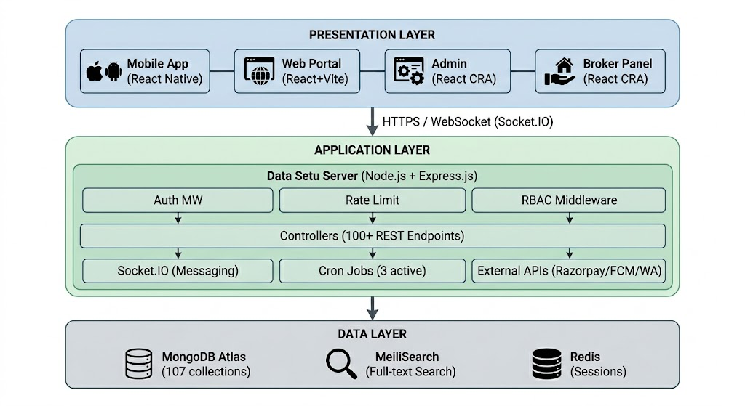

The Presentation Layer encompasses all client-facing applications the React Native mobile app, the React and Vite web portal, the React-based admin panel, and the broker panel. All four clients communicate exclusively with the Application Layer through HTTPS REST API calls and WebSocket connections for real-time messaging.
The Application Layer is the intellectual core of the platform. The Node.js and Express.js server hosts all business logic, authentication middleware, role-based access control, Socket.IO real-time messaging, scheduled cron jobs, and integrations with external third-party services. It exposes over 100 REST endpoints organized into logical route groups and maintains no client session state all context is derived from JWT tokens on every request.
The Data Layer consists of MongoDB Atlas as the primary document store with 107 Mongoose collections, MeiliSearch as the full-text search engine synchronized with the business user collection, and Redis for lightweight session caching and OTP storage during the authentication flow.

3.4 Component Design

3.4.1 Mobile Application Component Structure
The React Native mobile application is organized into a layered component hierarchy that separates navigation, screens, reusable components, MobX stores, and service utilities.
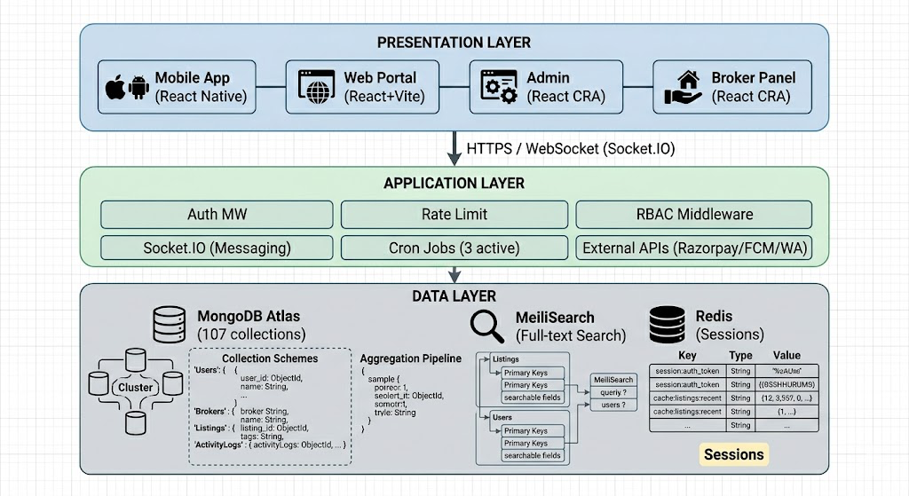

3.4.2 Backend Server Component Structure
The Express.js server is organized following the Model-Controller-Route pattern with additional layers for middleware, utilities, and external service integrations.
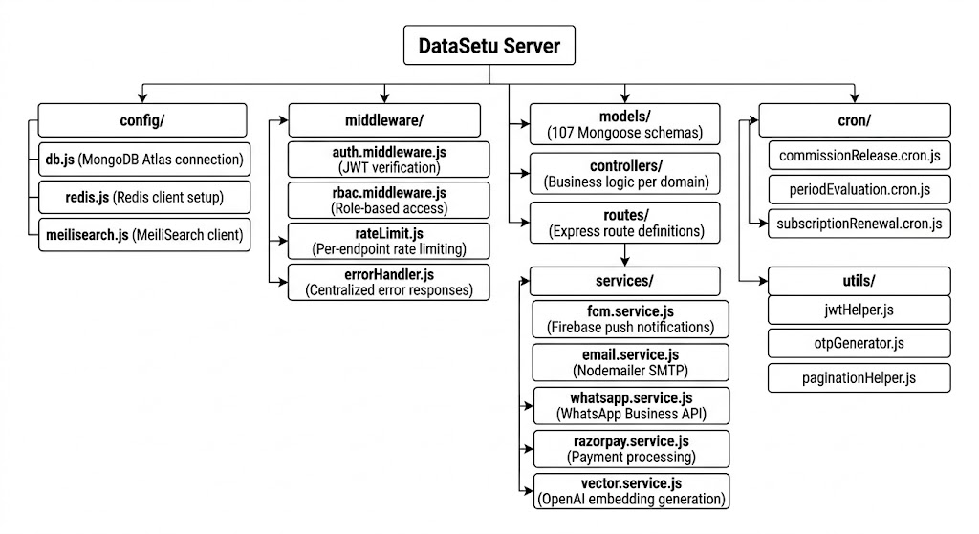

3.4.3 Notification Architecture
Every significant platform event triggers a coordinated multi-channel notification dispatch. The notification architecture ensures users are informed through the most appropriate channel depending on the event type and user preference.
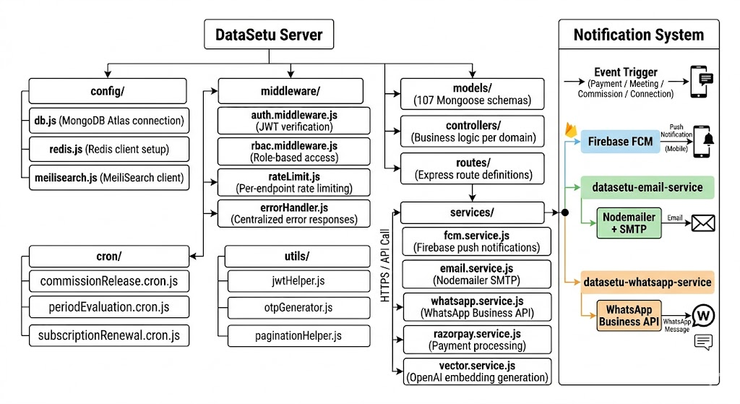
3.4.4 Associate Commission State Machine
The associate commission system is implemented as a formal state machine where every commission record transitions through defined states based on broker performance and administrative actions.
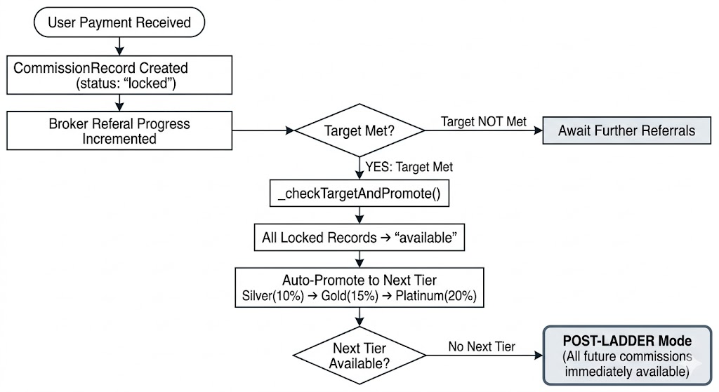
3.5 Data Structure and Database Design

3.5.1 Database Overview
Data Setu uses MongoDB Atlas as its primary database with 107 Mongoose collections. The document model was chosen over a relational schema for its flexibility in handling the evolving and deeply nested data structures characteristic of a B2B networking platform. Collections are logically grouped into six functional domains.

3.5.2 Core Collections
Collection | Purpose | Key Fields
BusinessUser | Core verified business directory | name, email, industry[], city, embedding_vector[3072]
RegisteredUser | Platform-registered app users | plan, referredByBrokerId, loyaltyPoints, fcmToken
BusinessProfile | Extended professional profiles | company, designation, products[], description
UserIndustry | Industry classification mapping | userId, industryId, isPrimary
ConnectionRequest | Business network graph edges | fromUser, toUser, status, createdAt
BlockedUser | Blocked connection records | blockedBy, blockedUser, reason

3.5.3 Meeting and Communication Collections
Collection | Purpose | Key Fields
Meeting | B2B meeting records | participants[], agenda[], format, status, location
MeetingParticipant | Per-participant meeting status | meetingId, userId, status, responseAt
Conversation | Chat conversation threads | participants[], lastMessageAt, isActive
Message | Individual chat messages | conversationId, senderId, content, readBy[], timestamp
Notification | In-app notification records | userId, type, title, body, isRead, metadata

3.5.4 Subscription and Payment Collections
Collection | Purpose | Key Fields
Plan | Subscription plan definitions | name, credits, validityDays, priceInr, features[]
Transaction | Unified payment records | userId, planId, platform, razorpayOrderId, amountInr, status
AppleSubscription | iOS receipt storage | userId, receiptData, productId, expiryDate
UserCredit | Credit balance ledger | userId, totalCredits, usedCredits, expiryDate
CreditTransaction | Credit usage history | userId, amount, type, referenceId

3.5..5 Associate and Commission Collections
Collection | Purpose | Key Fields
ReferralPartner | Broker/Associate profiles | brokerCode, commissionPlanId, lockedBalance, availableBalance
CommissionPlan | Tier definitions | tierName, percentage, targetCount, nextTierId
CommissionRecord | Individual commission entries | brokerId, userId, amount, status, transactionId
WithdrawalRequest | Withdrawal workflow records | brokerId, amount, status, bankDetails, processedAt
ReferralTarget | Broker progress tracking | brokerId, currentCount, currentTierId, isPostLadder

3.5.6 Loyalty and Engagement Collections
Collection | Purpose | Key Fields
LoyaltyTransaction | Loyalty points ledger | userId, points, type, description, createdAt
Coupon | Discount coupon records | code, discountValue, expiryDate, isUsed, assignedTo
WhatsAppTemplate | WhatsApp message templates | templateName, variables[], category, status
EmailTemplate | Email campaign templates | subject, bodyHtml, variables[], campaign

3.5.7 Technology Stack
Layer | Technology | Version | Purpose
Mobile App | React Native | Expo SDK 54 | Cross-platform iOS and Android application
Mobile State | MobX | 6.x | Reactive state management with persistent stores
Mobile Navigation | React Navigation | v7 | Stack, Bottom Tab, and Material Top Tab navigators
Web Portal | React + Vite | React 18 | Browser-based desktop user portal
Admin Panel | React (CRA) | React 18 | Super-admin management interface
Broker Panel | React (CRA) | React 18 | Associate referral and commission dashboard
Backend Runtime | Node.js | 20.x LTS | Server-side JavaScript runtime
Backend Framework | Express.js | 4.x | RESTful API server framework
Database | MongoDB Atlas | 7.x | Cloud-hosted NoSQL document database
ODM | Mongoose | 8.x | MongoDB object document mapper
Search Engine | MeiliSearch | 1.x | Full-text search with sub-50ms response
Real-Time | Socket.IO | 4.x | Bidirectional WebSocket communication
Authentication | JSON Web Token | RFC 7519 | Stateless role-based API authentication
Payments (India) | Razorpay | v2 API | UPI, card, and net banking payment processing
Payments (iOS) | Apple StoreKit | v2 | iOS In-App Purchase subscription management
Push Notifications | Firebase FCM | v1 API | Cross-platform mobile push delivery
Email Service | Nodemailer + SMTP | 6.x | Transactional email delivery
WhatsApp Service | WhatsApp Business API | Cloud API | Triggered and bulk WhatsApp messaging
AI Embeddings | OpenAI text-embedding-3-large | — | 3072-dimensional business profile vectorization
Vector Search | MongoDB Atlas Vector Search | — | Cosine similarity-based business recommendations
Caching | Redis | 7.x | OTP storage and lightweight session caching
Security Headers | Helmet.js | 7.x | HTTP security header enforcement
Input Sanitization | express-mongo-sanitize | 2.x | MongoDB injection prevention
Rate Limiting | express-rate-limit | 7.x | Per-IP and per-endpoint request throttling
Password Hashing | bcrypt | 5.x | Salted password hashing (10 rounds)
Logging | Winston + Daily Rotate | 3.x | Structured application logging with rotation
File Validation | file-type | 18.x | MIME-type validation for uploaded files
Parameter Protection | hpp | 0.2.x | HTTP parameter pollution prevention

Chapter 4 -Results and Discussion

4.1 Overview
The development of Data Setu concluded successfully with all core features implemented, tested, and validated across the mobile application, web portal, admin panel, and broker panel. The platform was subjected to performance benchmarking, security auditing, and a structured commission system validation all of which confirmed the system's readiness for real-world deployment.

4.2 Implemented Features and Performance
The following table summarizes the implementation status and key performance metrics of the platform's major features.
Feature / Metric | Status / Result
OTP-Based Authentication | Complete 10-min TTL, rate limited to 5 requests per 15 min
Verified Business Directory | Complete Profile completion gate enforced
AI-Powered Business Recommendations | Complete 3072-dimensional vector embeddings
MeiliSearch Full-Text Search | Complete Sub-50ms response time
Meeting Management | Complete Physical, virtual, and hybrid formats
Real-Time In-App Messaging | Complete Socket.IO with persistent history
Razorpay Payment Integration | Complete Web and Android
Apple In-App Purchases | Complete iOS with server-side receipt validation
Associate Commission System | Complete Tiered, auto-promoting, 19/19 test cases passed
Loyalty Points and Coupons | Complete Earn, redeem, and expiry enforced
Multi-Channel Notifications | Complete FCM, WhatsApp, and Email
Admin Panel | Complete Full CRUD, exports, campaign management
Broker Panel | Complete Dashboard, targets, withdrawal workflow
Contact Sync and Invite | Complete Device phonebook integration
Average API Response Time | < 200ms
Concurrent Socket.IO Connections | 500 connections tested
MongoDB Vector Search Response | < 500ms for 10-nearest-neighbor
Commission Calculation Accuracy | 100% across all 19 test cases
Referral Deep Linking | Partial Firebase Dynamic Links planned
Renewal Commission Automation | Partial Full automation in next cycle

4.3 Platform Launch
Data Setu was officially launched on 30th April 2026 in a formal event attended by BNI (Business Network International) members and industry stakeholders. The launch was accompanied by a press conference marking the platform's entry into the B2B digital networking space. BNI members formed the platform's initial verified user base, providing Data Setu with a strong and credible foundation of active business professionals from day one. Their onboarding validated the platform's core networking and referral workflows under real-world conditions, and the response from the attendees affirmed the genuine market need that Data Setu was built to address. The launch represented a significant milestone transitioning the platform from an academic development project to a live, publicly accessible product serving real business users.

4.4 Security Audit Findings
A comprehensive security audit was conducted prior to launch, identifying and resolving five vulnerabilities JWT secret exposure in legacy configuration files, missing rate limiting on the OTP endpoint, unvalidated file uploads permitting non-image types, MongoDB injection via unsanitized query parameters, and missing RBAC enforcement on three admin endpoints. All identified vulnerabilities were fully resolved before the platform went live, ensuring a secure foundation for production deployment.

4.5 Key Challenges and Solutions
The development of Data Setu presented several non-trivial engineering challenges. Apple's In-App Purchase framework required server-side receipt validation and subscription status polling, which was addressed by implementing an AppleSubscription model with a dedicated cron job for renewal detection. Concurrent payment webhooks firing for the same broker created a risk of duplicate commission records, which was resolved through a unique index on the transactionId field in the CommissionRecord collection ensuring idempotency. Storing 3072-dimensional vectors for a large user base introduced index size concerns, addressed through lazy embedding generation vectors are computed only upon profile completion rather than at registration. Finally, iOS's stricter contact access permissions compared to Android were handled through expo-contacts with a graceful permission denial fallback presenting a manual invite option to the user.

Chapter 5 - Conclusions and Future Scope

5.1 Summary of Work
Data Setu set out with a clear and ambitious goal to build a comprehensive, production-grade B2B networking and associate management platform that addresses the real, unmet needs of India's 63 million MSMEs. Over the course of the project, spanning eleven development sprints across six phases, the team designed and implemented a full-stack, cross-platform ecosystem comprising a React Native mobile application, a React and Vite web portal, a Node.js and Express.js backend server, a super-admin control panel, and an associate broker dashboard all operating over a unified API infrastructure of over 100 endpoints and 107 MongoDB collections.
Every objective outlined at the beginning of this project was met. A verified business directory with AI-powered semantic recommendations was built and deployed. A structured meeting management system supporting physical, virtual, and hybrid formats was implemented. Real-time in-app communication via Socket.IO was integrated alongside a multi-channel notification infrastructure spanning Firebase push notifications, WhatsApp Business API, and transactional email. A tiered associate commission system the platform's most novel contribution was designed, implemented, validated against 19 test cases, and confirmed to be race-condition safe, idempotent, and calculation accurate. The platform was secured through a defense-in-depth security architecture, load tested for concurrent usage, and successfully launched to real users on 30th April 2026.

5.2 Key Achievements
The project delivered five significant achievements that collectively define Data Setu's contribution.The first is the creation of a unified cross-platform ecosystem a single backend serving four distinct client applications across mobile, web, administration, and broker management demonstrating the viability of a monolithic API architecture for a feature-rich, multi-role platform at this scale.

5.3 Broader Significance
Beyond its technical contributions, Data Setu demonstrates something more fundamental that modern open-source technologies, when thoughtfully combined and carefully engineered.
The project also reaffirms the relevance of software engineering principles layered architecture, role-based access control, event-driven notifications, idempotent payment processing, and document database design in solving real-world problems at scale. These are not abstract concepts confined to textbooks; they are the practical tools that made Data Setu possible.
5.4 Future Scope
Data Setu's current implementation represents the foundation of a significantly larger vision. In the short term, the immediate priorities include completing Firebase Dynamic Links-based referral deep linking to replace the removed Branch.io integration, automating subscription renewal detection for full lifecycle commission tracking, and integrating Jitsi Meet or Daily.co WebRTC for in-app video conferencing.

Over the medium term, the platform roadmap includes multi-language support for Hindi, Gujarati, and Marathi to expand accessibility across India's linguistic diversity, ML-based fraud detection for the commission system, CRM integration with platforms like Zoho and HubSpot, a real-time analytics dashboard for administrators, and a B2B marketplace enabling platform-facilitated product and service transactions.

In the long term, Data Setu envisions blockchain-based decentralized business identity verification for tamper-proof credential authentication, an LLM-powered in-app AI business assistant to help users compose connection requests, generate meeting agendas, and draft proposals, and a pan-India expansion to 500,000 registered businesses through a hybrid model combining regional physical chapter coordinators with the platform's digital infrastructure ultimately positioning Data Setu as the defining B2B networking ecosystem for India's digital economy.

References

[1] R. T. Fielding, "Architectural Styles and the Design of Network-based Software Architectures," Ph.D. dissertation, Dept. Comput. Sci., Univ. of California, Irvine, CA, USA, 2000.
[2] K. Chodorow, MongoDB: The Definitive Guide, 2nd ed. Sebastopol, CA, USA: O'Reilly Media, 2013.
[3] P. Lubbers, B. Albers, and F. Salim, Pro HTML5 Programming, 2nd ed. New York, NY, USA: Apress, 2011.
[4] M. B. Jones, J. Bradley, and N. Sakimura, "JSON Web Token (JWT)," Internet Engineering Task Force, Fremont, CA, USA, RFC 7519, May 2015.
[5] E. Biyalogorsky, E. Gerstner, and B. Libai, "Customer Referral Management: Optimal Reward Programs," Marketing Science, vol. 20, no. 1, pp. 82–95, Jan. 2001.
[6] P. Schmitt, B. Skiera, and C. Van den Bulte, "Referral Programs and Customer Value," Journal of Marketing, vol. 75, no. 1, pp. 46–59, Jan. 2011.
[7] Y. Koren, R. Bell, and C. Volinsky, "Matrix Factorization Techniques for Recommender Systems," IEEE Computer, vol. 42, no. 8, pp. 30–37, Aug. 2009.
[8] T. Mikolov, I. Sutskever, K. Chen, G. Corrado, and J. Dean, "Distributed Representations of Words and Phrases and their Compositionality," in Proc. 26th Int. Conf. Neural Inf. Process. Syst. (NIPS), Lake Tahoe, NV, USA, 2013, pp. 3111–3119.
[9] D. S. Evans and R. Schmalensee, Matchmakers: The New Economics of Multisided Platforms. Boston, MA, USA: Harvard Business Review Press, 2016.
[10] D. L. Duffy, "Affiliate Marketing and Its Impact on e-Commerce," Journal of Consumer Marketing, vol. 22, no. 3, pp. 161–163, 2005.

Appendix

